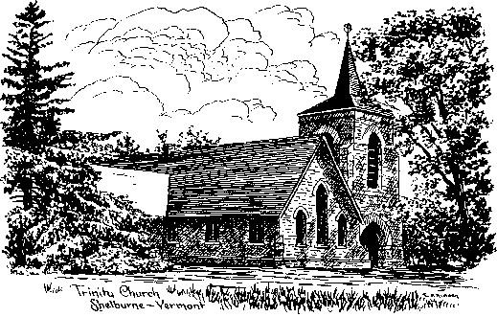
Trinity Episcopal Church, Shelburne, VT
5171 Shelburne Road, Shelburne, VT 05482 office@trinityshelburne.org 802-985-2269
The Rt. Rev. Dr. Shannon MacVean-Brown, Bishop
The Rev. Fr. Tommy Shephard, Rector, 901-921-0426
Michael Hartigan, Parish Musician
Liturgist and Officiant: Peg Jarvis

The Seventeenth Sunday After Pentecost, Year A, Proper 20
September 20, 2026, 9:30 a.m.; Morning Prayer – Hybrid
Thank you for worshiping with us this morning! We are glad you are here. If you are online, please keep your microphone muted for most of the service. If you are online reading a lesson, or offering an intercession or thanksgiving during the prayers, please unmute yourself; then re-mute.

Music is in this bulletin, and may be taken from The Hymnal 1982; Wonder, Love, and Praise (WLP); Lift Every Voice and Sing II (LEVAS II); Voices Found (VF); and My Heart Sings Out (MHSO).

Permission to reproduce music in this bulletin and to use recorded music is provided through

ONE LICENSE, License No. A-700287. The liturgy is from The Book of Common Prayer (BCP) and its supplement Enriching Our Worship (EOW).
Prelude
Opening Hymn
Rise up, ye saints of God Hymnal 551
Opening Sentence
Officiant

God is Spirit, and those who worship must worship in spirit and in truth.
John 4:24
Confession of Sin
Officiant

Let us confess our sins to God.

Silence may be kept.

Officiant and People

God of all mercy,
we confess that we have sinned against you,
opposing your will in our lives.
We have denied your goodness in each other,
in ourselves, and in the world you have created.
We repent of the evil that enslaves us,
the evil we have done,
and the evil done on our behalf.
Forgive, restore, and strengthen us
through our Savior Jesus Christ,
that we may abide in your love
and serve only your will. Amen.

Absolution/Prayer for Forgiveness

Officiant
Almighty God have mercy on us, forgive us all our sins through our Lord Jesus Christ, strengthen us in all goodness, and by the power of the Holy Spirit keep us in eternal life. Amen.
The Invitatory and Psalter
Officiant O God, let our mouth proclaim your praise.
People And your glory all the day long.
All Praise to the holy and undivided Trinity, one God: as it was in the beginning, is now, and will be for ever. Amen.
Officiant The Holy One is in our midst:
People O come let us worship.
Deus misereatur Psalm 67:1-5
Officiant and people together
O God, be merciful to us and bless us, *
show us the light of your countenance and come to us.
Let your ways be known upon earth, *
your saving health among all nations.
Let the peoples praise you, O God; *
let all the peoples praise you.
Let the nations be glad and sing for joy, *
for you judge the peoples with equity and guide all the nations upon earth.
Let the peoples praise you, O God; *
let all the peoples praise you.

Officiant The Holy One is in our midst:
People O come let us worship.

Psalm of the Day: Psalm 145:1-8

Read responsively by Verse
1 I will extol you, my God and King,*
and bless your name forever and ever.
2 Every day I will bless you*
and praise your name forever and ever.
3 Great is the LORD and greatly to be praised;*
his greatness is unsearchable.
4 One generation shall extol your works to another*
and shall declare your mighty acts.
5 They will recount the glorious splendor of your majesty,*
and on your wondrous works, I will meditate.
6 They will proclaim the might of your awesome deeds,*
and I will declare your greatness.
7 They shall celebrate the fame of your abundant goodness*
and shall sing aloud of your righteousness.
8 The LORD is gracious and merciful,*
slow to anger and abounding in steadfast love
Doxology
All Praise to the holy and undivided Trinity, one God:
as it was in the beginning, is now, and will be for ever. Amen.
The Lessons

First Reading: Jonah 3:10-4:11 Bill Currier
When God saw what they did, how they turned from their evil ways, God changed his mind about the calamity that he had said he would bring upon them, and he did not do it. But this was very displeasing to Jonah, and he became angry. He prayed to the LORD and said, "O LORD! Is not this what I said while I was still in my own country? That is why I fled to Tarshish at the beginning, for I knew that you are a gracious and merciful God, slow to anger, abounding in steadfast love, and relenting from punishment. And now, O LORD, please take my life from me, for it is better for me to die than to live." And the LORD said, "Is it right for you to be angry?" Then Jonah went out of the city and sat down east of the city and made a booth for himself there. He sat under it in the shade, waiting to see what would become of the city. The LORD God appointed a bush and made it come up over Jonah, to give shade over his head, to save him from his discomfort, so Jonah was very happy about the bush. But when dawn came up the next day, God appointed a worm that attacked the bush, so that it withered. When the sun rose, God prepared a sultry east wind, and the sun beat down on the head of Jonah so that he was faint and asked that he might die. He said, "It is better for me to die than to live."
But God said to Jonah, "Is it right for you to be angry about the bush?" And he said, "Yes, angry enough to die." Then the LORD said, "You are concerned about the bush, for which you did not labor and which you did not grow; it came into being in a night and perished in a night. And should I not be concerned about Nineveh, that great city, in which there are more than a hundred and twenty thousand persons who do not know their right hand from their left and also many animals?"

Lector: Hear what the Spirit is saying to God’s people.
People: Thanks be to God.
A period of silence is kept.
A Song of Jerusalem Our Mother Isaiah 66:10-14
All Say

Rejoice with Jerusalem and be glad for her *
all you who love her,

Rejoice, rejoice with her, *
all you who mourn over her,

That you may drink deeply with delight *
from her comforting breast.

For thus says our God, *
“I will extend peace to her like a river,
the wealth of nations like an overflowing stream.

“You shall nurse and be carried on her arm,
and you shall nestle in her lap.

“As a mother comforts her child, so will I comfort you; *
you shall be comforted in Jerusalem.

“You shall see, and your heart shall rejoice, *
you shall flourish like the grass of the fields.”

Second Reading: Philippians 1:21-30 Gail Currier
For to me, living is Christ and dying is gain. If I am to live in the flesh, that means fruitful labor for me; yet I cannot say which I will choose. I am hard pressed between the two: my desire is to depart and be with Christ, for that is far better, but to remain in the flesh is more necessary for you. Since I am convinced of this, I know that I will remain and continue with all of you for your progress and joy in faith, so that, by my presence again with you, your boast might abound in Christ Jesus because of me. Only, live your life in a manner worthy of the gospel of Christ, so that, whether I come and see you or am absent and hear about you, I will know that you are standing firm in one spirit, striving side by side with one mind for the faith of the gospel and in no way frightened by those opposing you. For them, this is evidence of their destruction, but of your salvation. And this is God's doing. For he has graciously granted you the privilege not only of believing in Christ but of suffering for him as well, since you are having the same struggle that you saw I had and now hear that I still have.
Lector : Hear what the Spirit is saying to God’s people
People: Thanks be to God.
A period of silence is kept.
A Song of Our Adoption Ephesians 1:3-10

All Say
Blessed are you, the God and Father of our Lord Jesus Christ,*
for you have blessed us in Christ with every spiritual blessing in the heavenly places.

Before the world was made, you chose us to be yours in Christ, *
that we should be holy and blameless before you.

You destined us for adoption as your children through Jesus Christ,*
according to the good pleasure of your will,

To the praise of your glorious grace, *
that you have freely given us in the Beloved.

In you, we have redemption through the blood of Christ, the forgiveness of our sins, according to the riches of your grace *
which you have lavished upon us.

You have made known to us, in all wisdom and insight, *
the mystery of your will,

According to your good pleasure which you set forth in Christ, *
as a plan for the fullness of time,

To gather together all things in Christ, *

things in heaven and things on earth.

The Gospel: Matthew 20:1-16 Lynn Bates

(In Morning Prayer, all remain seated while the Gospel is read by a layperson.)

When the days drew near for Jesus to be taken up, he set his face to go to Jerusalem. And he sent messengers ahead of him. On their way they entered a village of the Samaritans to make ready for him; but they did not receive him, because his face was set toward Jerusalem. When his disciples James and John saw it, they said, "Lord, do you want us to command fire to come down from heaven and consume them?" But he turned and rebuked them. Then they went on to another village.
As they were going along the road, someone said to him, "I will follow you wherever you go." And Jesus said to him, "Foxes have holes, and birds of the air have nests; but the Son of Man has nowhere to lay his head." To another he said, "Follow me." But he said, "Lord, first let me go and bury my father." But Jesus said to him, "Let the dead bury their own dead; but as for you, go and proclaim the kingdom of God." Another said, "I will follow you, Lord; but let me first say farewell to those at my home." Jesus said to him, "No one who puts a hand to the plow and looks back is fit for the kingdom of God."

Lector : Hear what the Spirit is saying to God’s people
People: Thanks be to God.
A period of silence is kept.
Sermon Christine Faris
The Apostles' Creed

Officiant and People together, standing as able

I believe in God, the Father almighty,
creator of heaven and earth.

I believe in Jesus Christ, God’s only Son, our Lord.
who was conceived by the Holy Spirit
born of the Virgin Mary,
suffered under Pontius Pilate,
was crucified, died, and was buried;
he descended to the dead.
On the third day he rose again;
he ascended into heaven,
He is seated at the right hand of the Father,
and he will come again to judge the living and the dead.

I believe in the Holy Spirit,
the holy catholic Church,
the communion of saints,
the forgiveness of sins
the resurrection of the body,
and the life everlasting. Amen.

The Prayers

The people stand or kneel

Officiant God be with you.
People And also with you.
Officiant Let us pray.
Officiant and People
Our Father in heaven, hallowed be your Name, your kingdom come, your will be done, on earth as in heaven. Give us today our daily bread. Forgive us our sins as we forgive those who sin against us. Save us from the time of trial, and deliver us from evil. For the kingdom, the power, and the glory are yours, now and for ever. Amen.
Suffrages
V. Help us, O God our Savior;
R. Deliver us and forgive us our sins.
V. Look upon your congregation;
R. Give to your people the blessing of peace.
V. Declare your glory among the nations;
R. And your wonders among all peoples.
V. Do not let the oppressed be shamed and turned away;
R. Never forget the lives of your poor.
V. Continue your loving-kindness to those who know you;
R. And your favor to those who are true of heart.
V. Satisfy us by your loving-kindness in the morning;
R. So shall we rejoice and be glad all the days of our life.
The Collect of the Day
Almighty God, you have built your Church upon the foundation of the apostles and prophets, Jesus Christ himself being the chief cornerstone: Grant us so to be joined together in unity of spirit by their teaching, that we may be made a holy temple acceptable to you; through Jesus Christ our Lord, who lives and reigns with you and the Holy Spirit, one God, for ever and ever. Amen.
A Collect for the Human Family
Said in Unison
O God, you made us in your own image and redeemed us through Jesus your Son: Look with compassion on the whole human family; take away the arrogance and hatred which infect our hearts; break down the walls that separate us; unite us in bonds of love; and work through our struggle and confusion to accomplish your purposes on earth; that, in your good time, all nations and races may serve you in harmony around your heavenly throne; through Jesus Christ our Lord. Amen.
A Collect for Peace
Said in Unison
Eternal God, in whose perfect kingdom no sword is drawn but the sword of righteousness, no strength known but the strength of love: So mightily spread abroad your Spirit, that all peoples may be gathered under the banner of the Prince of Peace, as children of one Father; to whom be dominion and glory, now and for ever. Amen.
A Collect for Mission
Said in Unison
Almighty and everlasting God, by whose Spirit the whole body of your faithful people is governed and sanctified: Receive our supplications and prayers which we offer before you for all members of your holy Church, that in their vocation and ministry they may truly and devoutly serve you; through our Lord and Savior Jesus Christ. Amen.
Office/Offertory Hymn
Give praise and glory unto God Hymnal 375
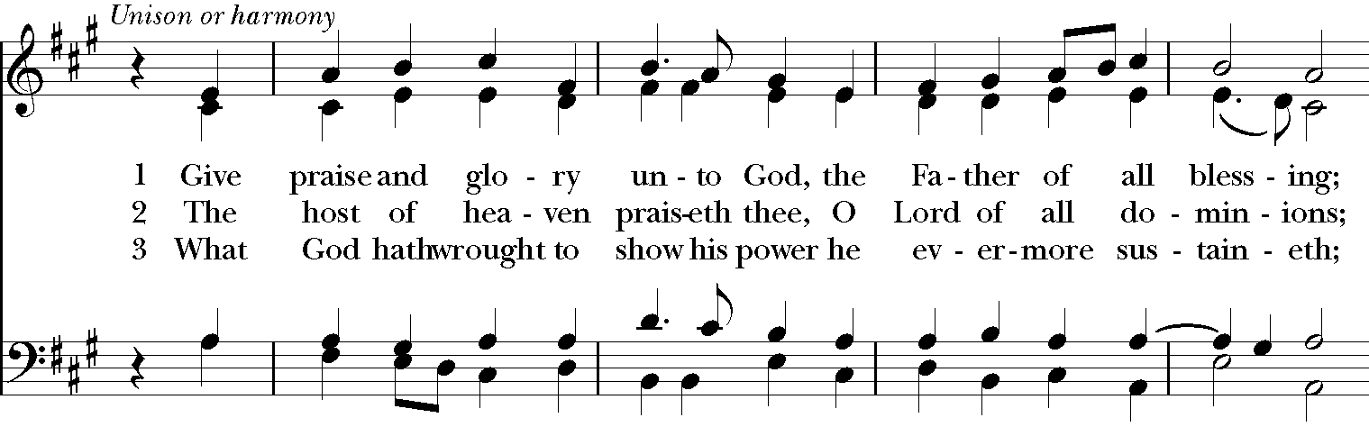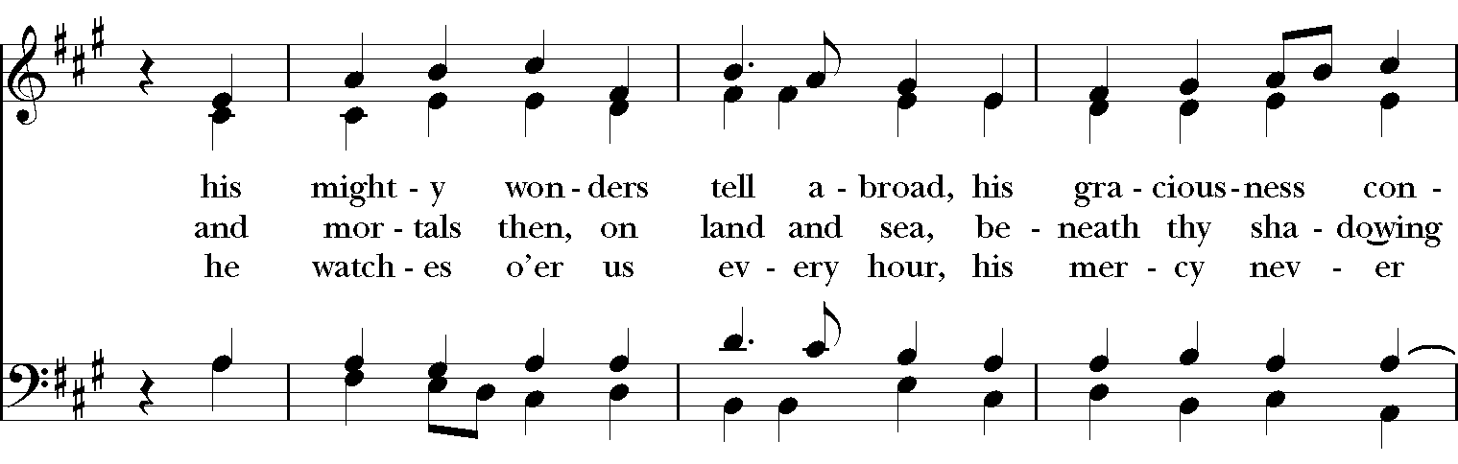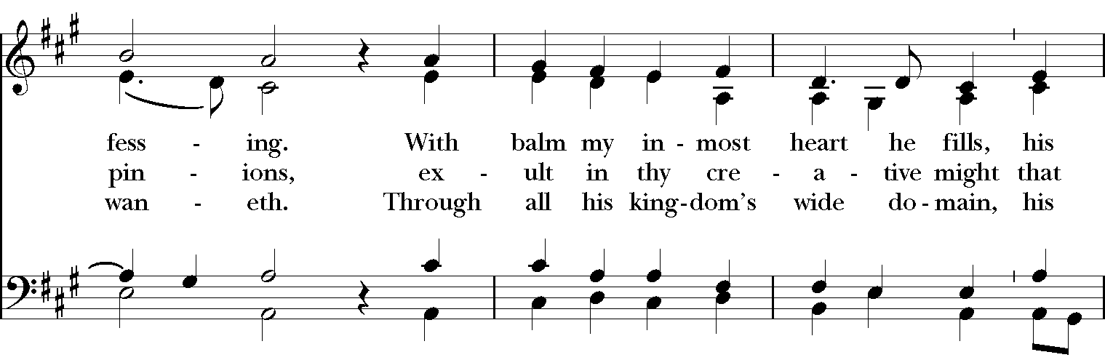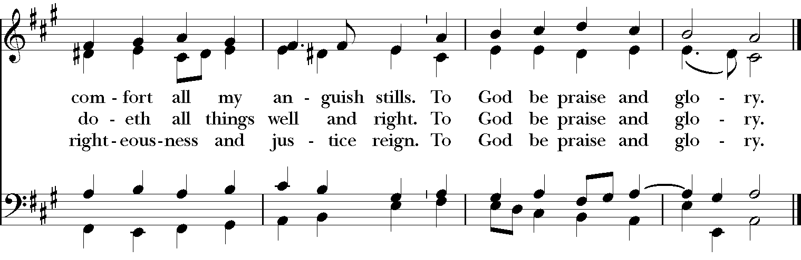
Local Intercessions and Thanksgivings
Authorized intercessions and thanksgivings may follow.
Please remember to unmute before speaking in the silence that follows each bidding.
We remember The Constellation of Grace Church, Sheldon and St. Luke’s, St. Albans; the Rev. Darcey Mercier; and the Rev. Jim Ballard in our Diocesan Cycle of Prayer, and we pray for The Anglican Church of Australia in our Anglican Cycle of Prayer.
We pray for all who celebrate birthdays or anniversaries this week, especially those we now name …
Silence
We pray for those who are sick or have asked for our prayers, especially those we now name …
Silence
We pray for those who have died, remembering especially those we now name …
Silence
I invite your additional prayers of thanksgiving and intercession at this time. …
Silence
Concluding Collect

Almighty and eternal God, ruler of all things in heaven and earth: Mercifully accept the prayers of your people, and strengthen us to do your will; through Jesus Christ our Lord. Amen.
A Prayer of St. Chrysostom
All
Almighty God, you have given us grace at this time with one accord to make our common supplication to you; and you have promised through your well-beloved Son that when two or three are gathered together in his Name you will be in the midst of them: Fulfill now, O Lord, our desires and petitions as may be best for us; granting us in this world knowledge of your truth, and in the age to come life everlasting. Amen.
Dismissal
Officiant Let us bless the Lord.
People Thanks be to God.
Concluding Sentence
The Officiant says
Glory to God whose power, working in us, can do infinitely more than we can ask or imagine: Glory to God from generation to generation in the Church, and in Christ Jesus for ever and ever. Amen. Ephesians 3:20,21
Sending Hymn
We all are one in mission WLP 778
Postlude
Announcements
Eucharistic Minister Training
Training for those who serve at the altar will take place immediately after the service on 9/27
Fall Cleanup at Trinity
Join the Fall Grounds Cleanup October 10
Trinlty will hold its fall cleanup of the church grounds from 9-11 a.m. on Saturday, October 10. Please come with any tools you have -- rakes, clippers, shovels, trimmers, etc. We'll get beds ready for winter, trim and prune. We got a great start on cleaning up the church grounds this spring and inside the church this summer so let's keep up the momentum! Please contact Sarah Ray at sclarksonray@gmail.com if you have any questions.
Trinity Times Newsletter
Gail is working on the next issue of the Trinity Times with a publishing date by the end of the month. If you have photos, stories, recipes, etc. please send them to Gail via email at gailcurrier@gmail.com
Planning Center Training at Trinity
On Sunday, September 27, following coffee hour, we will offer a training session on Planning Center. Everyone is welcome, especially those who would appreciate additional help using the system. Fr. Tommy will help with installing the Planning Center apps and provide guidance on how to use them.
Trinity Book Group Reconvenes September 22
Trinity’s Tuesday Book Group will reconvene on September 22 at 5:00 p.m. on Zoom. The group will finish Adam Hamilton’s The Lord’s Prayer by reviewing section five and discussing section six. Anyone interested in joining is welcome. A Zoom link will be shared before the meeting. Contact Diane Rooney via email at dianerooney123@gmail.com to be added to the list.
St. Andrews YouTube
St. Andrew’s YouTube Page is http://www.youtube.com/standrewsvtorg for those who might want to watch Fr. Tommy’s sermons.
Calendar
Today: Coffee Hour, McClure Room
Tuesday, 9/22: Book Group, 5:00 PM on Zoom, (dianerooney123@gmail.com)
Saturday, 9/26: Funeral for Zach Clements, 11:00 AM
Next Sunday: Sunday School, Holy Eucharist, 9:30 AM
Eucharistic Minister Training, Planning Center Training after church
October 10: Fall Cleanup

A Note on Today’s Readings
The Seventeenth Sunday after Pentecost – Proper 20, the Sunday closest to September 21, Year A
Welcome to our parish. The theme of today’s liturgy is set by the Gospel reading. The parable of the laborers in the vineyard is one of Jesus’ most important statements concerning God’s call to all people. That call is always open regardless of our past level of commitment. Those who accept it late are rewarded equally with those of long standing in the Kingdom. It is also a warning to those who have been committed to God for many years, lest they think themselves superior to those newly responding to the call of God.
Jonah did not want to preach repentance to the city of Ninevah (one of the Jews’ greatest enemies) lest its people repent and God forgive them. However, after an amazing experience with a fish, Jonah complied. That God would forgive even Ninevah is one of the most striking messages in the Old Testament, expressing the universality of God’s love and forgiveness.
Today we begin reading Paul’s letter to Philippi. Written to encourage that church, the letter comes from a period when Paul was imprisoned and his own life was in danger.
God’s promise to us is not a reward for doing things right. It is our heritage as children and heirs of God’s promise. When we gather to sing and tell the story of God’s salvation, we discover anew our identity and the identity of all people. Not content to have us merely as creatures, God has made us sons and daughters who feast at the table of God’s home, which is our home as well.
Adapted from The Rite Light: Reflections on the Sunday Readings and Seasons of the Church Year. Copyright © 2007 by Michael W. Merriman. Church Publishing Incorporated, New York.

